**ASSIGNMENT 13.2**

**1. What are the names of all the countries in the databases which start with the letter "B"**

**(sorted by their names)?**

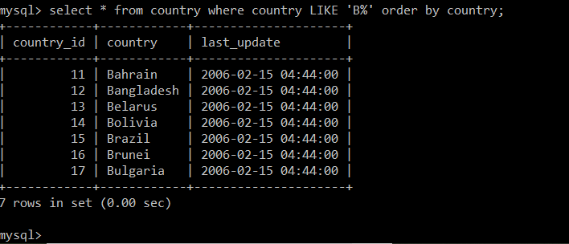

2. Return the first names (sorted) of all the actors with the last name "berry".

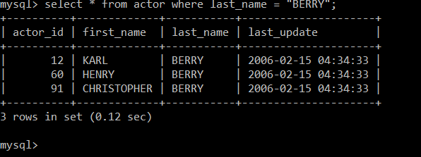

3. Find all the films whose length is more than 184 (inclusive). Order the results by the length

(and for films with the same length order them by their name). Return their title and the length.

